Moving Out example output

Function of daily spending

t

In this example, the first spending is for breakfast or a coffee. You do not spend more money until you drive to school. The slanted line is for driving to school. You do not technically spend money as you are driving, but you can think of your car spending your money.

To calculate your car’s spending, give an estimate of your car’s miles per gallon (mpg). Then, multiply it by the number of miles you drive (to school). This will give you the gallons of gasoline you have used. Multiply this by the cost of gasoline (you may use a full or half dollar amount as an estimate).

$$\$ for fuel=\frac{1}{mpg}*miles*\$ per gallon$$

$$\$ for fuel= \frac{gallon}{20 miles}*10 miles*\frac{\$ 4.50}{gallon}$$

$$\$ for fuel= \frac{10 gallon}{20 }* \frac{miles}{miles}*\frac{\$ 4.50}{gallon}$$

$$\$ for fuel= \frac{1}{2 }* \frac{miles}{miles}*\frac{\$ 4.50}{1}* \frac{gallon}{gallon}$$

Miles divided by miles = 1 and gallon divided by gallon = 1 so we are left with:

$$\$ for fuel= \frac{1}{2 }* \frac{\$ 4.50}{1}=- \$2.25$$

If we use 0.5 hours to get to school (or 0.25 hour since it is the smallest measure), you can determine the slope of that portion of the function. Since the money is flowing out, you know that it must be a negative slope. (The negative sign shows that the money is going out.)

$$slope of driving= \frac{cost of fuel}{driving time }= \frac{- \$ 2.25}{0.50 hour}=\frac{- \$4.50}{hour}$$

You can use the same calculation going home since the money is still flowing out.

Notice that the cost of breakfast and lunch hit at just one time so your outflow of money stays constant from the time you buy those meals until the next outflow of money. Also, note that the functions are not “continuous.” This means that there are places where one part of the function stops and another part continues. Since we know that time flows continuously, we must continue on the x-axis (t-axis in this case). But we must use the open circle to show that part of the function stops when another begins. The corners also show discontinuity, but that is just because the function is not smooth.

One way you can think of the money going out on a single transaction being a function and not a bunch of y-values for a single x-value is thinking that you do not pay a penny at a time when you buy something. If you did, you would not have a function because you are paying different amounts at the same time.

I do not have units on my example graph. This is because I want you to create your own graphs from your own data.

One last thing. If you operate on a cash basis, you can think of the function as the amount of cash you have in your pocket. If you do this, your graph will look the same, but it will have a different starting point. What will that starting point be?

Rent

Rent might seem like a simple function. Just a straight horizontal line. While this might be true after getting into a place, it is not true for the whole period. Typically, you have first and last months’ rents plus a deposit.

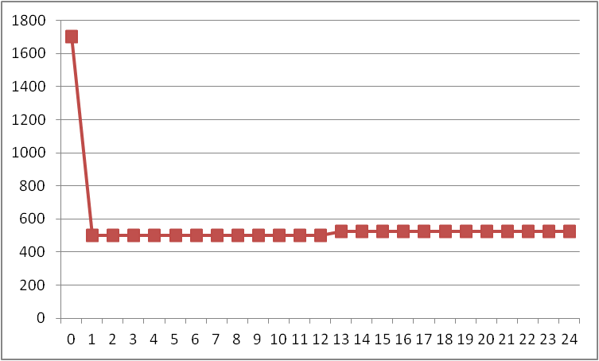

I did not use realistic values for rent or a deposit. I used $500 for rent and $700 for a deposit. The large amount that you pay even before you begin renting a place is for the first month’s rent, last month’s rent, and the deposit. This might be a realistic value if you were sharing a place with other people. Also note that there is a slight increase (5%) in rent the second year. The other thing to note is that this function is really not correct. It should actually just be the dots. You can think of it as “discrete” or individual payments and times. In mathematical terms, your domain (x-coordinate) is the whole number of months you are renting. The lower limit of the domain is the lowest rent you would pay and the upper limit is the amount you pay just to get into your apartment. In this case, your domain would be months 0 through 24 and your range would be $ 500 to $1700.

You will have similar functions and graphs for your other monetary needs. Since these are mostly monthly payments, they are also discrete functions.

You can and should add all your functions together so you can see a graph of your combined monetary outflow.

Wages and Savings

Create a function for savings. You will need to do this in conjunction with your income (wages). Save somewhere between 10% and 50% depending on how long you want to take to get there. You may include a specific amount that you start with if you have savings that you are already going to use to move out.

While this is technically a discrete function too, make it a continuous function. In other words, think of how much money you make per hour and use your chosen percentage per hour as the slope of a linear function. (It might be mostly linear if you decide that you have a job where you can earn overtime wages.)

Start with a weekly income (and savings). Then, create a graph of savings that assumes the same amount of wages for longer amount of time.

By the way, minors cannot work overtime. So these graphs, which assume a person working 60 hours per week, do not apply to you working now. The only legal way you can get around this restriction is to have your own business. The graph below is for an hourly wage of $5.00 per hour. At the very least, you should use minimum wage to create your functions.

